**Gross Pay, Annual Income and Income Tax Calculator**

Write a Python Program to make the gross pay, annual income and income tax calculator using following data.

The gross pay consists of Basic Pay, House Rent Allowance (hra), Dearness Allowance (dra), other allowances and professional tax and provident fund.

Gross Pay= Basic Pay+ House Rent Allowance (hra) + Dearness Allowance (dra) +other allowances +Transport Allowance (TA)– Professional tax –Employees’ Provident fund (EPF)

Basic Pay for different grade levels are indicated in table given.

The Professional tax remains constant and that is equal to 200 Rs. for each grade levels and each month.

House Rent Allowance (hra) varies as per the city- For Class 1 Cities it is 0.3 times of Basic Pay of each grade levels, for Class 2 Cities it is 0.2 times of Basic Pay of each grade levels, for Class 3 Cities it is 0.1 times of Basic Pay of each grade levels,

Dearness Allowance (dra)= 0.5 times of Basic Pay of each grade levels, Other allowances are given in table which varies according to different grade levels, Provident Fund= 0.11 times of Basic Pay for each grade levels, Transport Allowance remains constant as 900 Rs. for each levels.

For different grade pays:

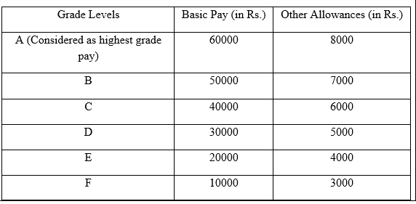

The gross pay calculated is only for one month.

After calculating Gross Pay of each employee calculate the annual pay for employee by multiplying gross pay calculated, by 12.

So, Annual Pay of an employee=Gross Pay of an employee*12

From Annual Pay of an Employee Calculate the income tax as per the slabs of India Income Tax 2022-23 given below.

Tax Slabs for AY 2022-23

